한국통계학회 생물통계연구회 하계 세미나
한국통계학회 생물통계연구회에서 Department of Biostatistics (& Dept of Radiological Sciences), UCLA 의 Grace Kim (김현정) 교수님과 국립암센터의 주정남 박사님을 모시고, 아래와 같이 하계 세미나를 개최합니다. 관심 있으신 연구자 여러분들의 많은 참석을 바랍니다.

일시: 2011년 8월 4일 목요일 오후 4:00-6:00
장소: 서울대학교 보건대학원 (관악캠퍼스 221동) 113호 강의실 (1층 강당)

연자 및 제목:
- Hyun Jung (Grace) Kim, Ph.D. (UCLA)
http://www.radnet.ucla.edu/radweb/research/faculty/Kim.jsp

“Evaluation Process of Imaging Biomarker: Quantitative Lung Fibrosis (QLF) Score for Computer Tomography (CT) Data in Interstitial Lung Disease”

- 주정남 박사 (국립암센터)

“Statistical Design Considerations for the Clarification of Optimal Anticoagulation through Genetics (COAG) Trial”

강의 초록:

- Hyun Jung (Grace) Kim, Ph.D.: "Evaluation Process of Imaging Biomarker: Quantitative Lung Fibrosis (QLF) Score for Computer Tomography (CT) Data in Interstitial Lung Disease"
Imaging modality can vividly show the treatment efficacy in therapeutic intervention. We need to develop and evaluate the vocabulary, imaging biomarker, for the treatment efficacy. The important factors in biomarker evaluation are calibration, discrimination and accuracy in multicenter clinical trial. To be qualified for imaging surrogates biomarker, many challenges are present in the calibration before applying to clinical trial and research application, because different technical factors create a different level of noise and affect to the measurement of imaging biomarker. We present a novel QLF, “biomarker”, of CT imaging: de-noise as part of calibration and comparison of radiologist score with QLF as discrimination and accuracy. We, then, show this imaging “biomarker”, QLF, as outcome variable for the treatment efficacy in the proven scleroderma-lung-disease clinical trial.

- 주정남 박사: “Statistical Design Considerations for the Clarification of Optimal Anticoagulation through Genetics (COAG) Trial”
The Clarification of Optimal Anticoagulation through Genetics (COAG) trial is a large, multicenter, double-blinded, randomized trial to determine whether the use of a genotype-guided dosing algorithm (using clinical and genetic information) to initiate warfarin treatment will improve anticoagulation status when compared to a dosing algorithm using only clinical information. The trial involves two possibly heterogeneous populations, which can be distinguished by the difference in warfarin dose as predicted by the two algorithms. A statistical approach is detailed, which allows an overall comparison as well as a comparison of the primary endpoint in the subgroup for which sufficiently different doses are predicted by the two algorithms. Methods of allocating alpha for these analyses are given – a prospective alpha allocation and allocating alpha so that the two analyses have equal power, which we call a ‘balanced alpha allocation’.
세미나 장소 오시는 길

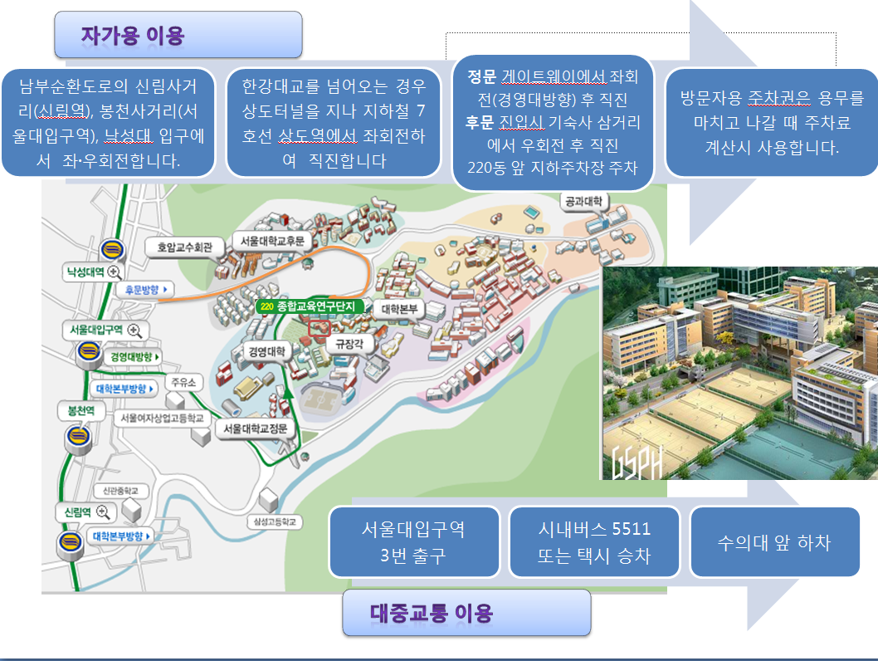
장소 문의: 010-5379-2366 (강민진)
010-8296-2222 (김샛별)

