한국통계학회 생물통계연구회 추계 정기세미나
한국통계학회 생물통계연구회에서 Department of Biostatistics & Epidemiology, University of Pennsylvania School of Medicine의 Daniel Francis Heitjan 교수님과 Department of Biostatistics, Columbia University 의 Myunghee Cho Paik 교수님을 모시고, 아래와 같이 추계 정기 세미나를 개최합니다. 관심 있으신 연구자 여러분들의 많은 참석을 바랍니다.

일시: 2011년 10월 26일 수요일 오후 4:00-6:00
장소: 서울대학교 보건대학원 (관악캠퍼스 221동) 113호 강의실 (1층 강당)

연자 및 제목:
- Myunghee Cho Paik, Ph.D. (Columbia University)

“Missing Data in Longitudinal Studies: An Alternative Approach to Handling Missing Data by Deleting”
- Daniel Francis Heitjan, Ph.D. (University of Pennsylvania)
http://www.cceb.upenn.edu/pages/heitjan/index.php

“Real-Time Prediction in Clinical Trials: A Statistical History of REMATCH”

강의 초록:

- Myunghee Cho Paik, Ph.D.: “Missing Data in Longitudinal Studies: An Alternative Approach to Handling Missing Data by Deleting”
Approaches to missing data in the literature can be classified as likelihood method, imputation or inverse probability weighting. We introduce a recently proposed easy-to-implement alternative approach namely deletion, and demonstrate how this approach can be applied in longitudinal settings such as GEE and Cox model with missing covariates. Different approaches will be compared via simulations and data analysis from Northern Manhattan Stroke Study.

- Daniel Francis Heitjan, Ph.D.: "Real-Time Prediction in Clinical Trials: A Statistical History of REMATCH"
Randomized clinical trials often include one or more planned interim analyses, during which an external monitoring committee reviews the accumulated data and determines whether it is scientifically and ethically appropriate for the study to continue. With survival-time endpoints, it is often desirable to schedule the interim analyses at the times of occurrence of specified landmark events, such as the 50th event, the 100th event, and so on. Because the timing of such events is random, and the interim analyses impose considerable logistical burdens, it is worthwhile to predict the event times as accurately as possible. Prediction methods available prior to 2001 used data only from previous trials, which are often of questionable relevance to the trial for which one wishes to make predictions. With modern data management systems it is often feasible to use data from the trial itself to make these predictions, rendering them far more reliable. This talk will describe work that some colleagues and students and I have done in this area. I will set the methodologic development in the context of the trial that motivated our work: REMATCH, a randomized clinical trial of a heart assist device that ran from 1998 to 2001 and was considered one of the most rigorous and expensive device trials ever conducted.

세미나 장소 오시는 길

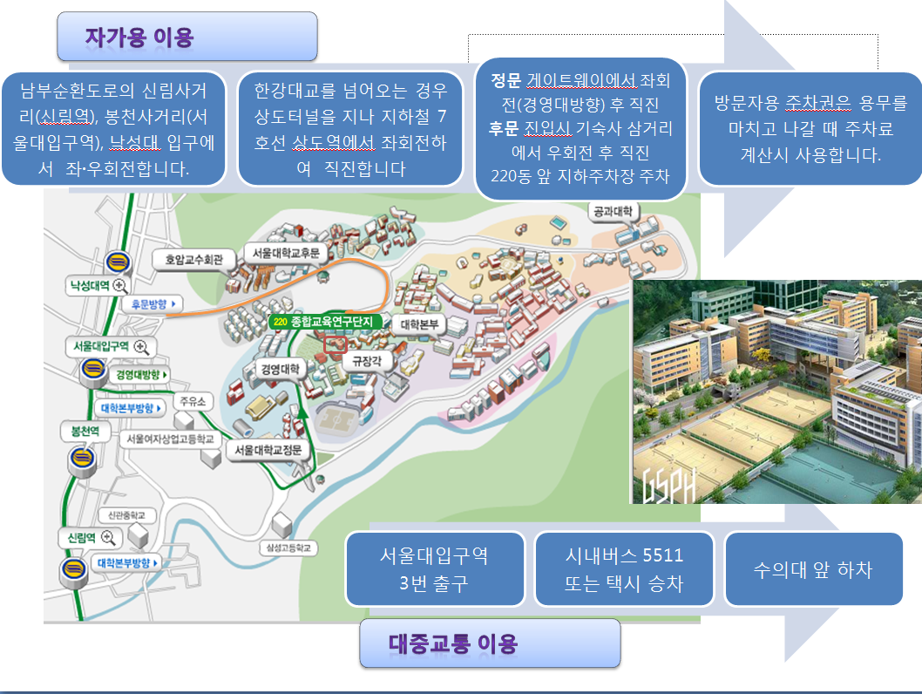
장소 문의: 010-5379-2366 (강민진)
010-8296-2222 (김샛별)

